Project Design Phase
Problem – Solution Fit Template
Date | 20 February 2026
Team ID | LTVIP2026TMIDS79198
Project Name | Resolve Now: Your Platform for Online Complaints
Maximum Marks | 2 Marks

Problem – Solution Fit:
Users face difficulty in registering and tracking complaints due to lack of a single platform.
Our Solution:
Resolve Now allows users to submit and track complaints easily in one place.
Purpose:
- Solve complaints easily.
- Improve transparency.
- Increase trust.
- Faster resolution.

Template:
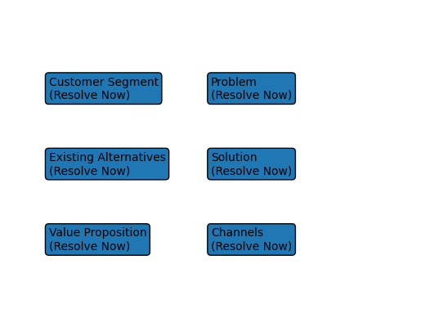

References:
https://www.ideahackers.network/problem-solution-fit-canvas/
https://medium.com/@epicantus/problem-solution-fit-canvas-aa3dd59cb4fe

